**EC2- Elastic cloud compute**- requesting AWS to give a virtual service which is elastic in nature

Elastic- Flexible multiple services are there, according to the need we can increase/decrease the resources.

Cloud- AWS Cloud

Compute- Which is a combination of CPU, ram and disk, asking AWS a virtual server

**WHY:**

Maintenance and cost

**Types of EC2:**

General Purpose: Balanced compute, memory, and networking resources. Suitable for web servers, small databases, and development/testing environments.

Compute optimized: Applications requiring high compute power, such as gaming, high-performance web servers, and scientific modelling.

Memory optimized: Applications requiring fast access to large datasets, such as in-memory databases, big data processing, and analytics.

Storage optimized: Workloads requiring high-speed local storage, such as data warehousing, Hadoop clusters, and NoSQL databases.

Accelerated computing type: Workloads requiring GPU-based computation, such as machine learning, AI inference, video processing, and high-performance computing (HPC).

**VPC: VIRTUAL PRIVATE CLOUD**: isolated cloud resources

subnets

Internet gateway

Public subnet

Elastic Load balancing

Route tables

Security group

Private ip ec2 instance

Ipv4-32, ipv6-128 – increasing usage, coz of shortage ipv6 also came into the play

**NACL: Network Access control List**

**Route53:**

**DNS Service**

**Domain name system**

**Besantazure1**

**VPC Peering:**

**Connecting one vpc to another vpc using private ip**

**--------------------------------------------------------------------------------------------------------------------------------------**

**ROUTE53:** provide DNS- Domain name service

Maps the domain name with ip address , ex: [www.amazon.com](http://www.amazon.com)

DNS: we can purchase the domain name from AWS or we can buy from goddady and integrate with AWS

**Health checking:**

Sends automated requests to your application to verify that it's available and functional

Using Route53 we can Update DNA Records using hosted zones

-------------------------------------------------------------------------------------------------------------------------------------------------------------------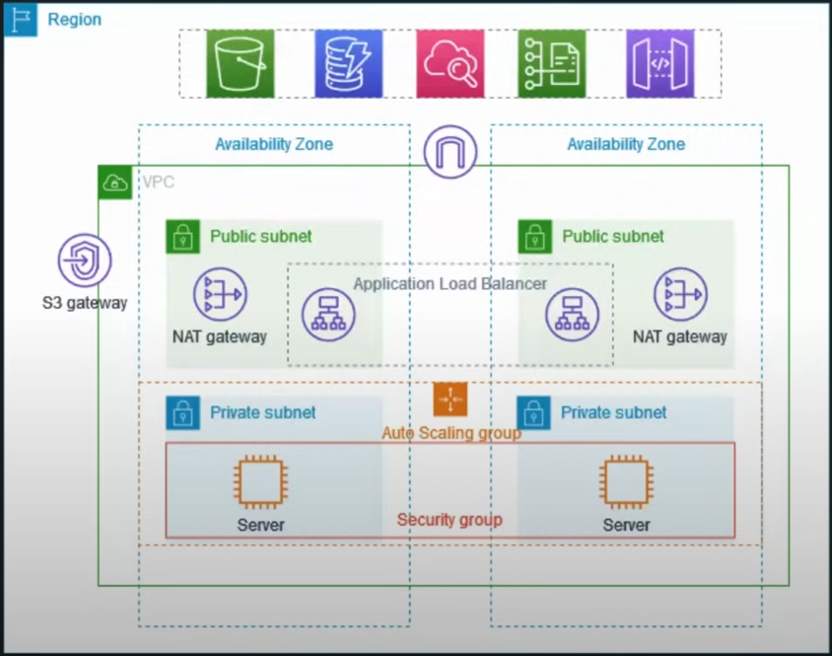

Auto scaling: scale a servers to 3,4,5 . it will split the servers when more traffics are coming ..

**An AWS load balancer** is a server that distributes incoming traffic from clients to registered targets, such as EC2 instances, in multiple Availability Zones. Load balancers improve application performance by: Increasing response time, Reducing network latency, and Improving fault tolerance.

Bastion-host- it acts as a mediator between private subnet and the external public subnet